Corey Gaspar
2/14/2026
6-1 Milestone: Dashboard Data Visualizations
Picture of the data table with the first entry selected.
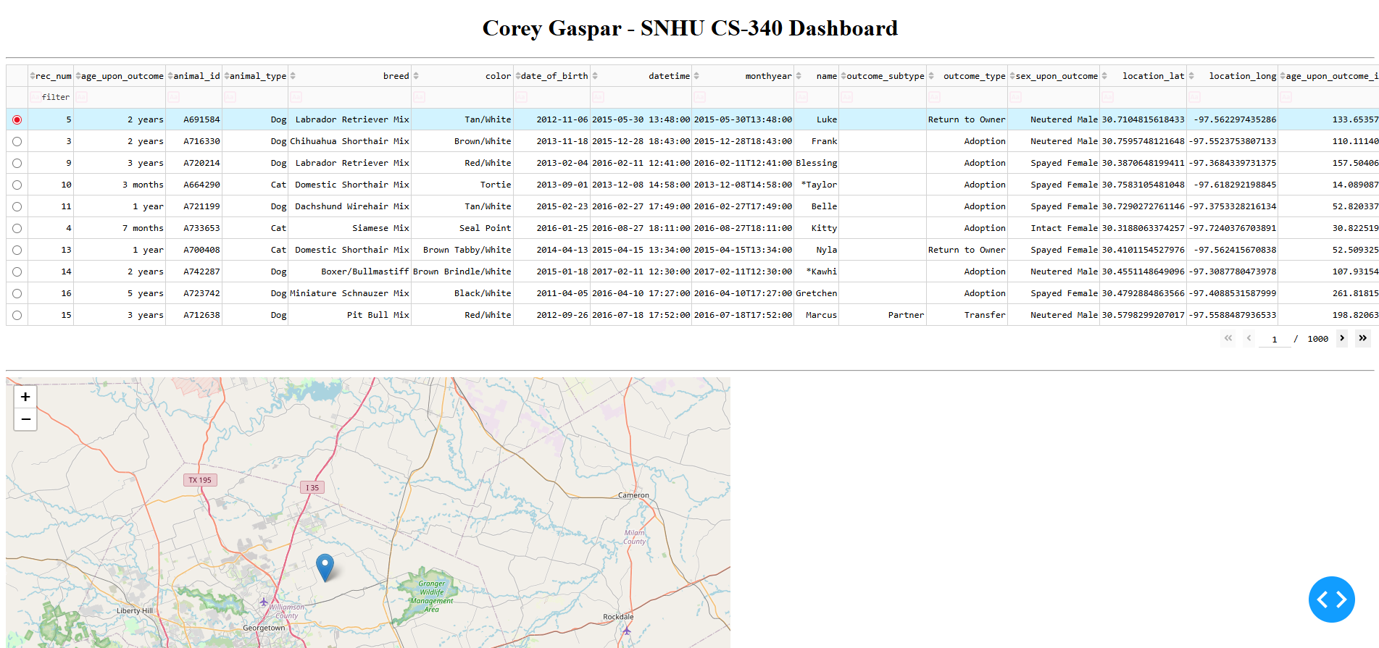
When selecting the pin on the map, more information about the entry is shown.
